I. PIVOT TABLES

Dataset: <https://www.kaggle.com/code/sadiqshah/bike-store-sales-in-europe/input>

Insert-Recommended Pivot tables - -these are pivot tables automatically made based on your data set

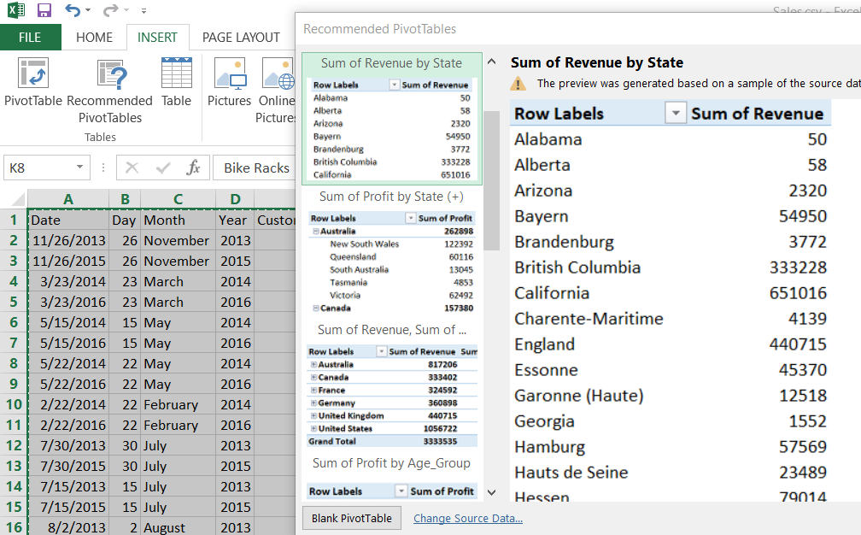

When creating new pivot table, it automatically selects everything

To select everything, DO NOT USE ctrl +A, USE crtl +shift + left key +down key

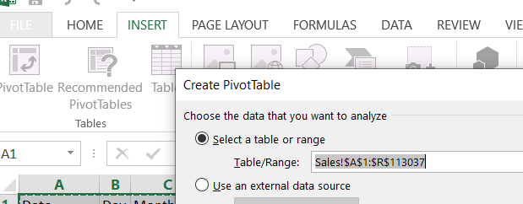

Hold ctrl + click any column names to add to the table/Range.

‘Sales’ is the filename. Columns and rows can be selected

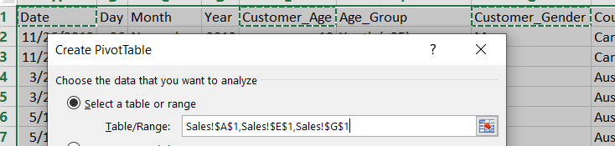 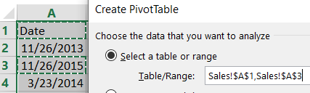

You can drag and drop the fields to the area such as FILTERS, COLUMNS, ROWS, and VALUES and it will automatically create table. What you drag in the value section will display the value, same with rows, columns, filters section

Home -> choose from the data type format like currency , date etc.

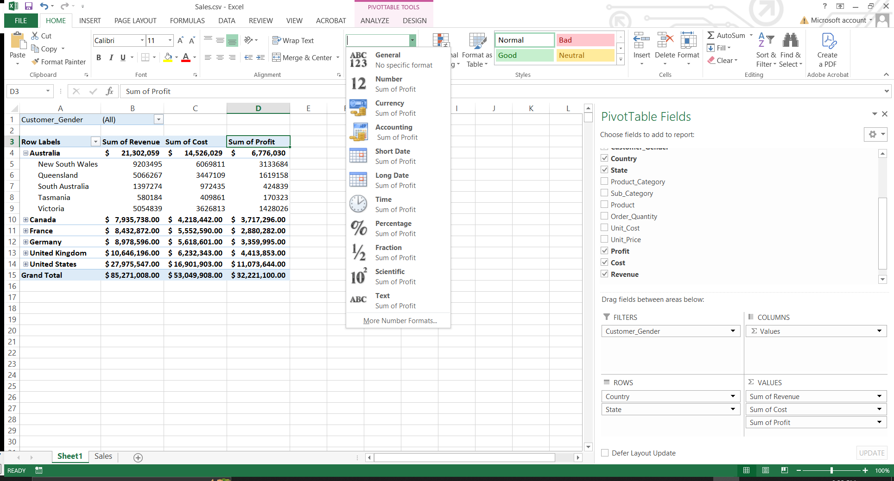

Value field settings- is where you can change what aggregate function like Count, Average etc, in the particular value column. Right click any items under values and the value settings will appear

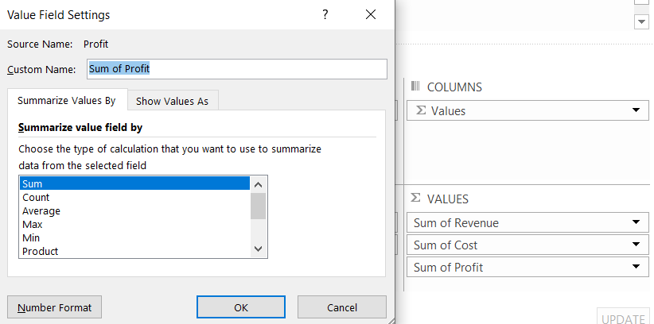

FILTERS - Anything you put in the filter will change the whole table value depending on the selection

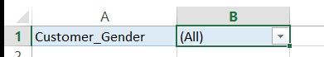 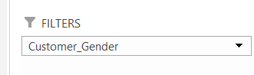

COLUMNS- Anything you drag under the column will automatically categorize data in that column

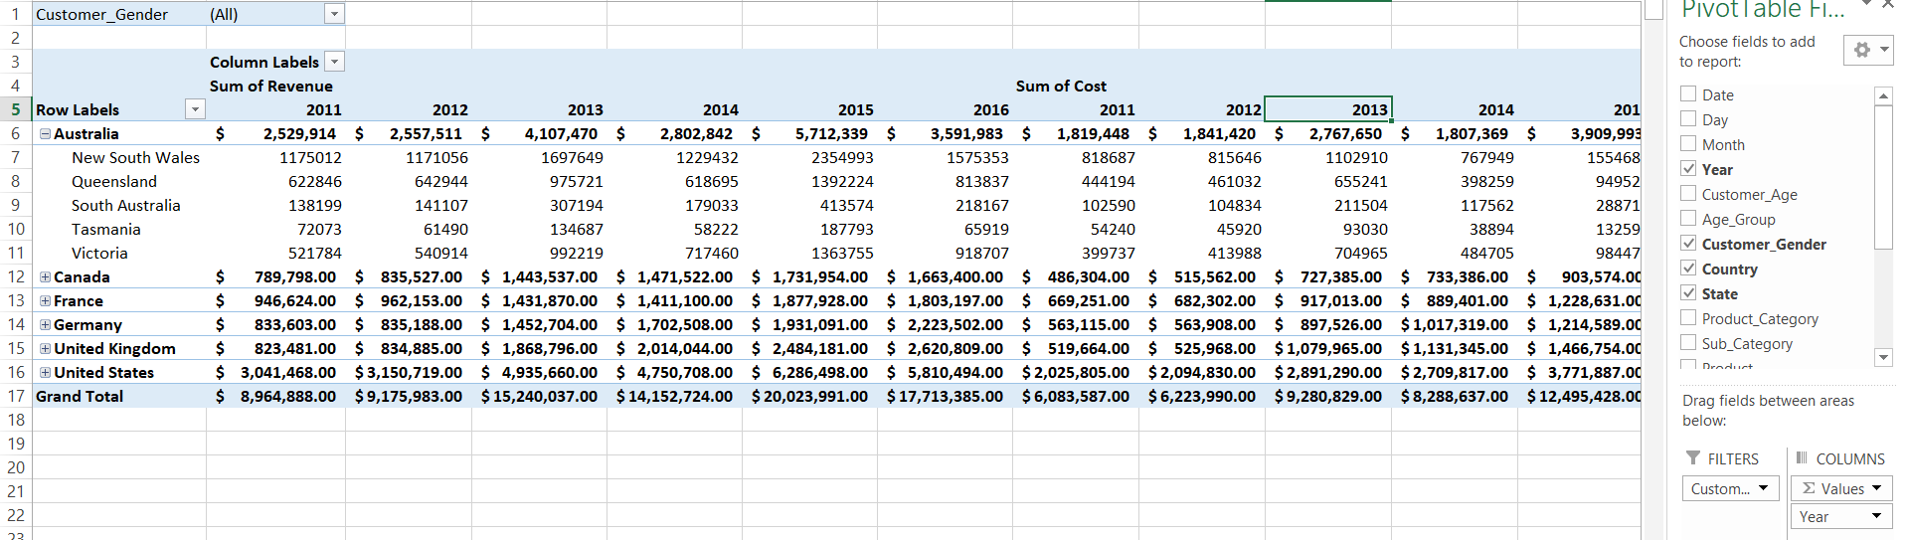

Calculated field – is where you can choose the calculation to be used and what column or rows to be calculated. It will become permanent field.

Analyze-> Fields, Items, &Sets -> Calculated field You can insert any field and use operations.

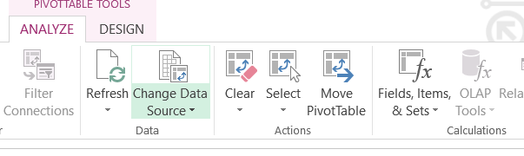 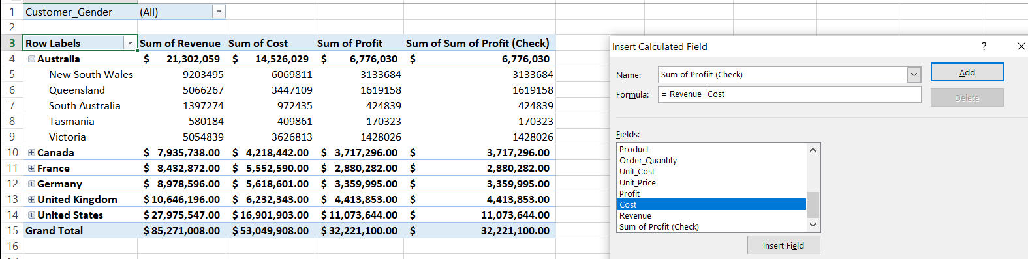

It will be added to PivotTable fields  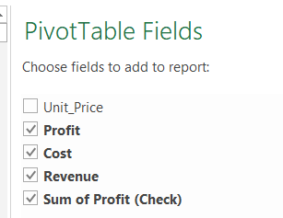

**FORMULAS IN EXCEL**

Dataset = Formula Excel Template.xlsx

1. MAX and MIN- just type ‘=MAX‘ then select the table range

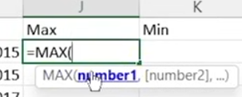 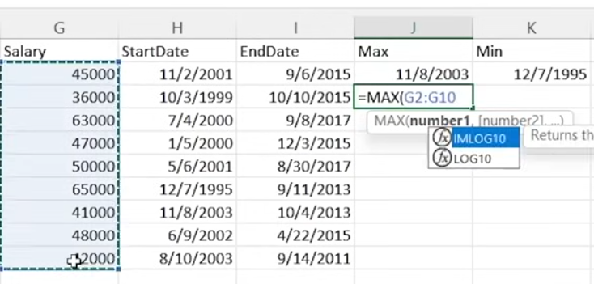

2. IF – same as if-else statement. Will return a data is true and false. The logical_test is the column range that are selected and used in a logical operator

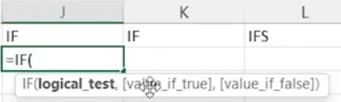

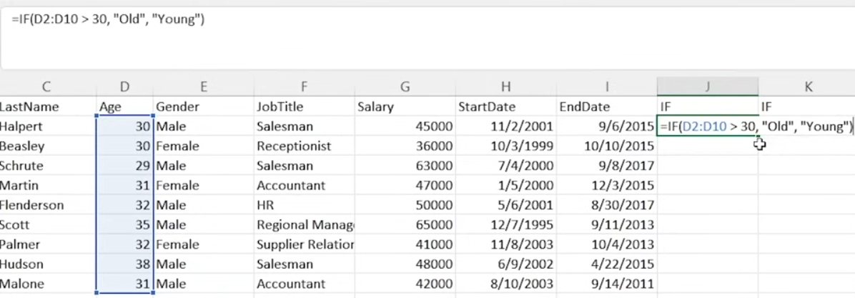

3. IFS- doesn’t return anything if the logic is false. ONLY RETURN VALUE OF TRUE

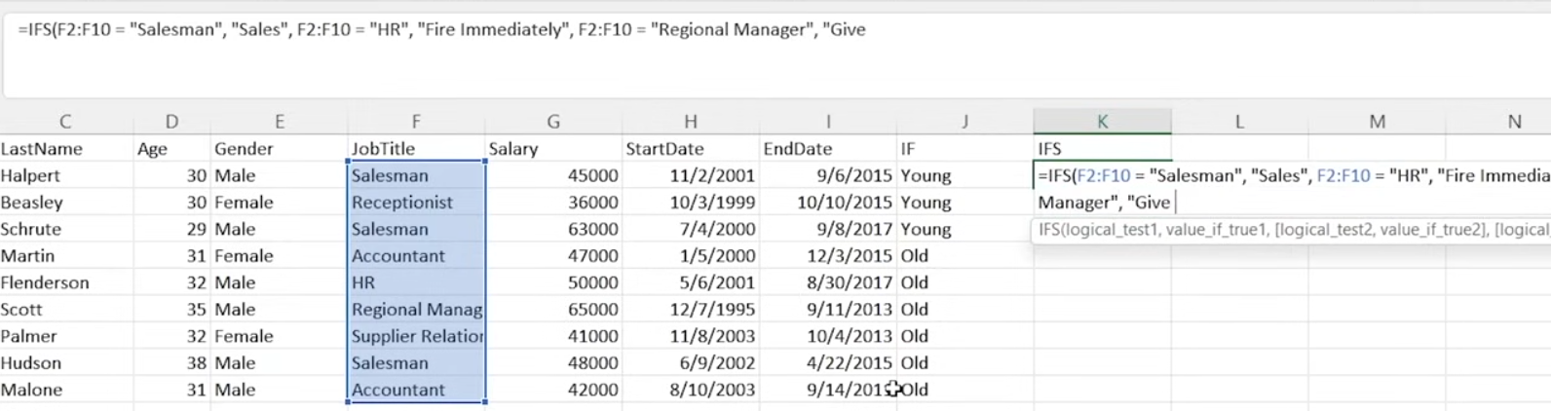

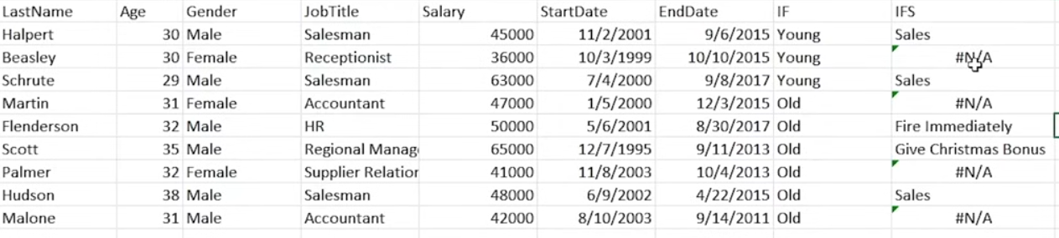

4. LEN –returns the number of characters in a text string format

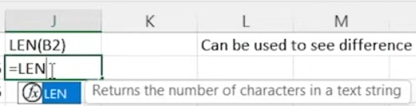

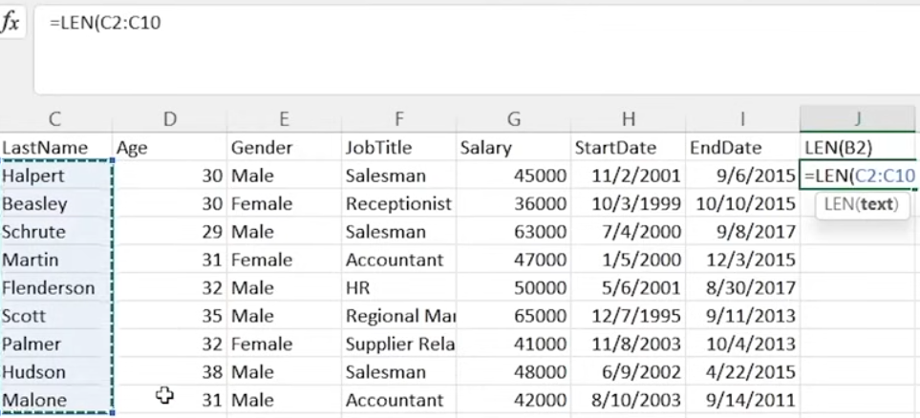 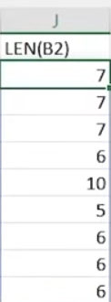

5. LEFT-RIGHT –like SUBSTRING in SQL. Extract from string, need to indicate number of chars

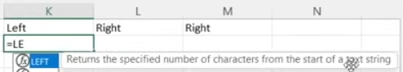 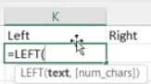

Left takes chars starting from left

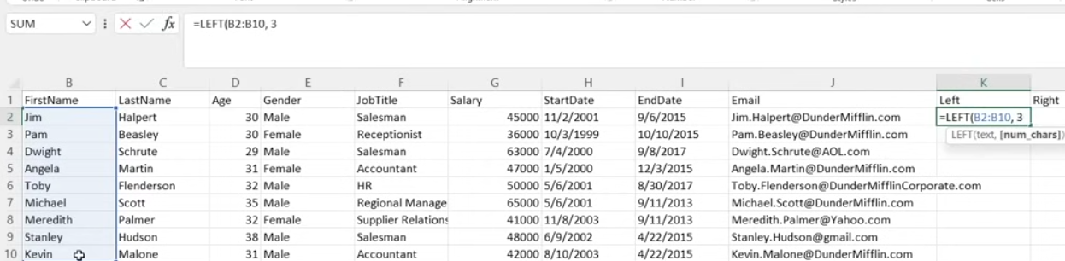 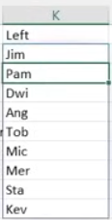

Remember: It can only extract in a ‘General’ or “Text’ datatype format

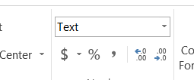 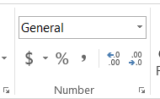

6. TEXT- converts value to text in a specific number format. Ex: Date To Text

Trying to extract in a date from at using RIGHT and LEFT will return the TEXT equivalent of the date

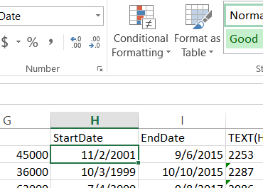 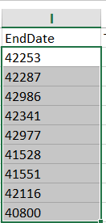EndDate converted to text

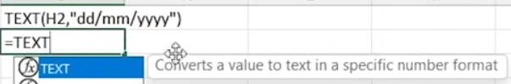 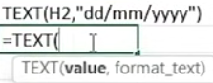

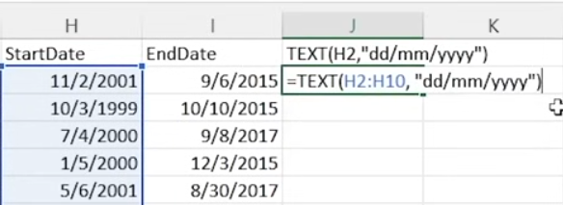 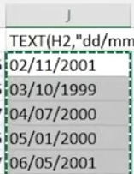

7. TRIM- Removes all spaces from a text string except for single spaces between words

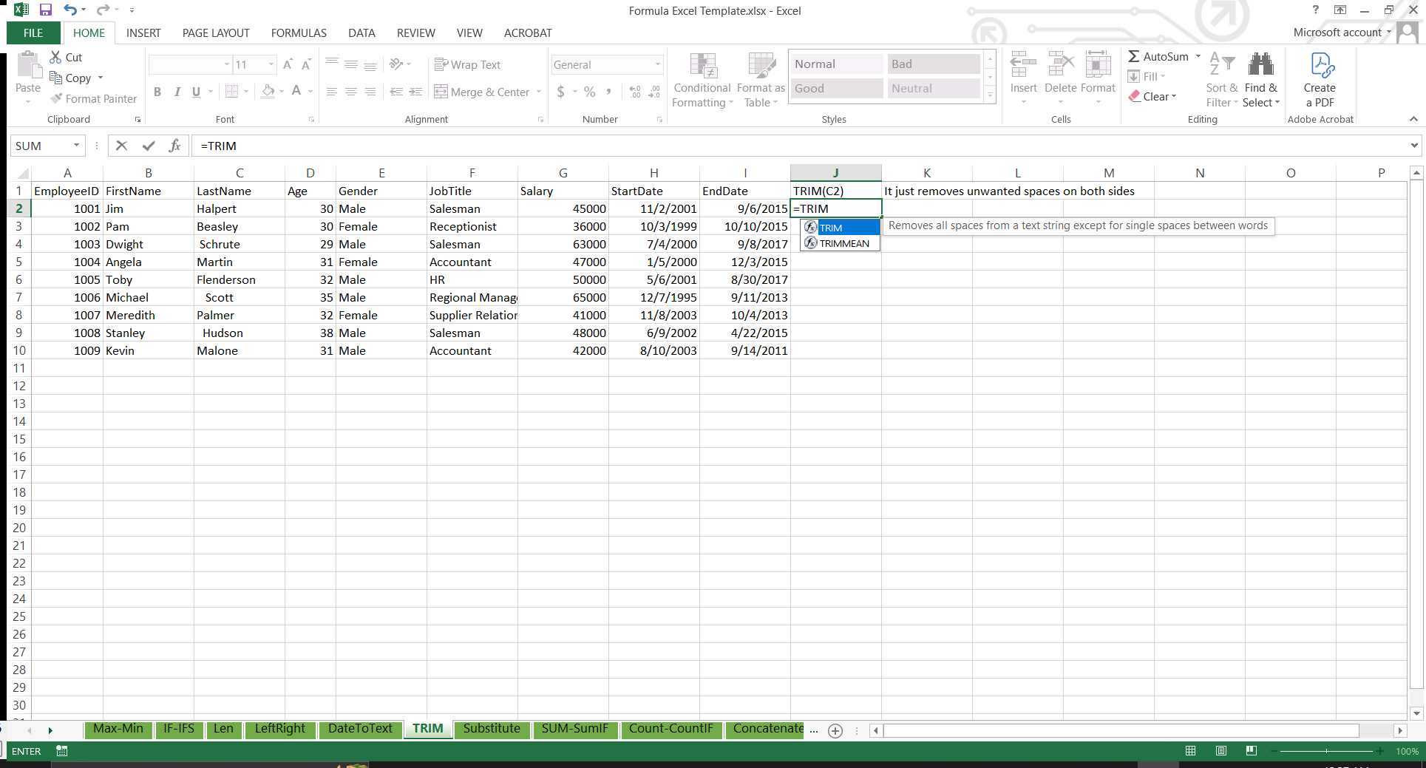

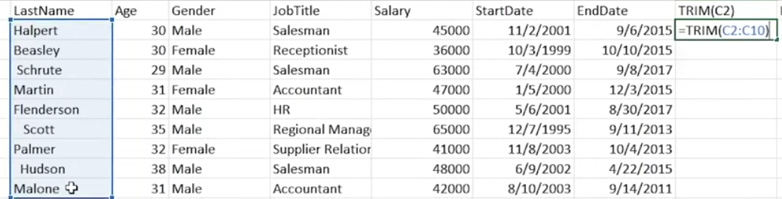

8. CONCATENATE – Joins several text strings into one text string

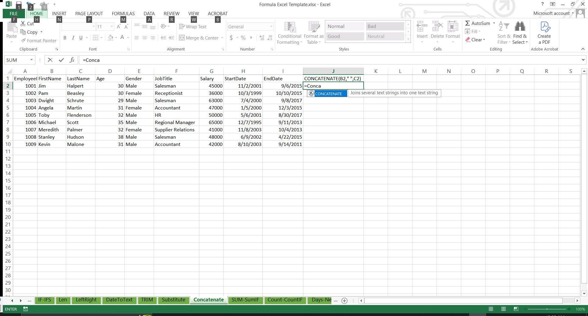

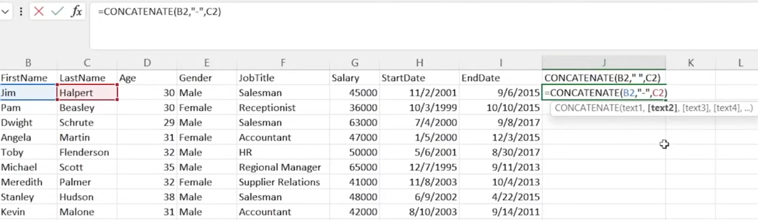 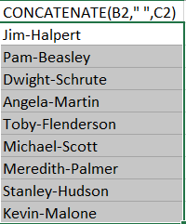

Useful for emails



9. SUBSTITUTE –Replaces existing text with new text in a text string

Without instances it will replace ALL the value indicated in the formula

 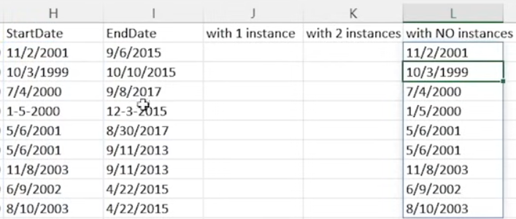 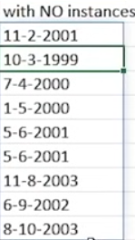

With 1(1st) instance, the first encounter of the text will be substituted. With 2 (2nd) instance, the first encounter is not touched but the second encounter is changed

 

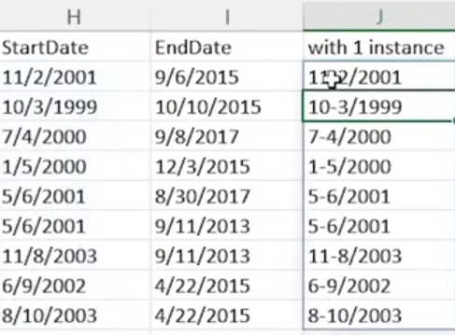 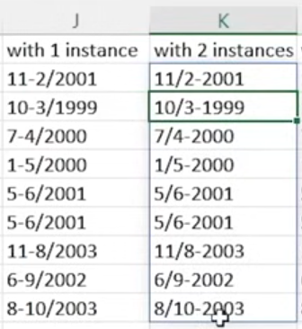

10. SUM, SUMIF, SUMIFS

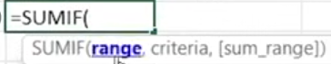

SUM are basic addition of all. SUMIF should have a condition

 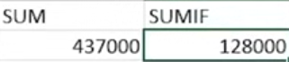

SUMIFS- have the range of the data the you will sum + criteria range with the criteria + another criteria range with the criteria. So in the example, the salary will only be sum if in the criteria range of ‘Gender’ has ‘female’ and a criteria range of “age” is >30

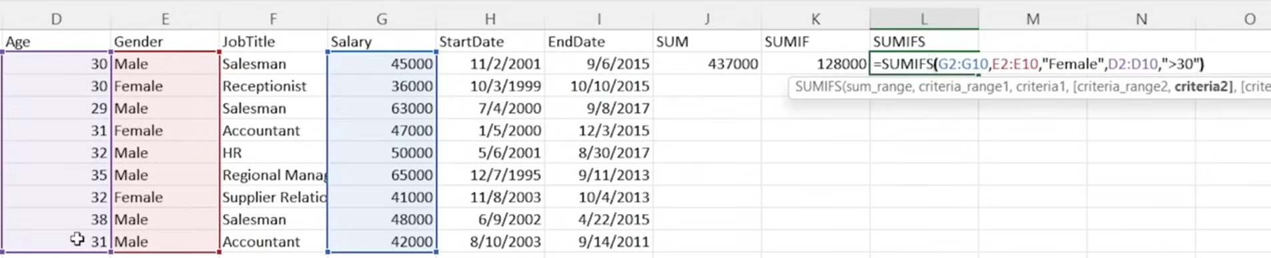

11. COUNT, COUNTIF, COUNTIFS- similar with SUM but it only counts NOT ADD

 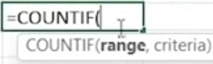 

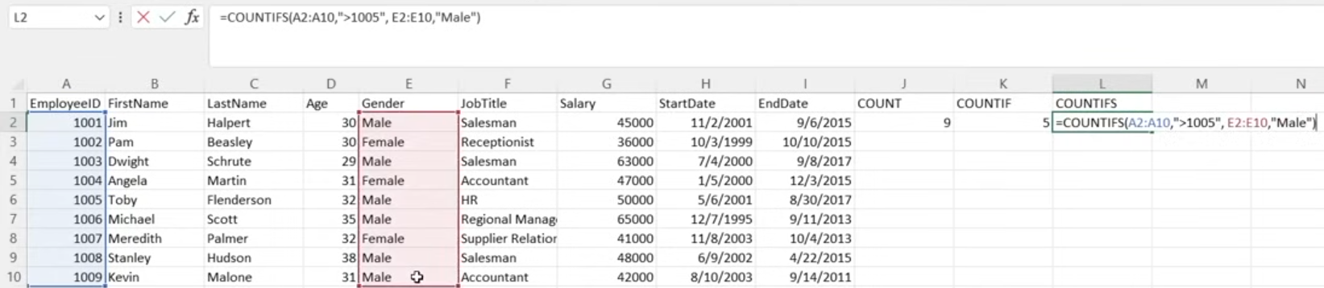

12. DAYS – returns the number of days between the two dates



13. NETWORKDAYS- returns the number of whole workdays between two dates. This means only working dates, HOLIDAYS AND WEEKENDS are NOT INCLUDED.

